**FUEL INVENTORY MANAGEMENT SYSTEM**

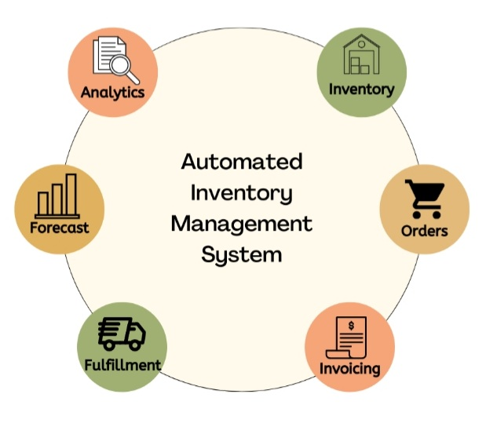

**RESEARCHER:** SHINGIRAI CHOGA CHIHURI

**CONTACT DETAILS/ CELL:** 0773 245 051

**DATE:** 10 MAY 2023

**TEAM NAME:** ZADOK

**TEAM LOGO:**

ZADOK

Investment

**SUPERVISOR:** SERVIOUS MBIZA

**SPONSORED BY:** ECONET ZIMBABWE`

**Chapter 1**

Abstract

Table of contents

List of Figures

1.1 Introduction/ Executive summary4

1.2 Organizational Background5

1.3 Problem Statement6

1.4 Project Aim7

1.5 Objectives7

1.6 Feasibility and planning8

1.6.1 Justification of the Study10

1.6.2 Business values10

1.6.3 Feasibility Study (Operational, technical and Economic)11

1.6.4 Risk Analysis17

1.6.5 Stakeholder Analysis20

1.6.6 Work Plan23

CHapter 2 system analysis

2.1 Data gathering methodologies employed26

2.2 Description of existing system28

2.3 Activity diagram29

2.4 DFD (Context and Detailed)31

2.5 Weakness of existing system33

2.6 Justification of alternative taken34

2.7 Requirements Analysis (Use Case Diagrams)35

chapter 3 system design

3.1 Proposed systems DFDs (Context and Detailed)37

3.2 Architectural design38

3.3 Menu design40

3.4 Input design41

3.5 Output design41

3.6 Process design (Pseudo code, Flow charts)42

3.7 Database design (DD, ER and EER diagrams)44

3.8 Program design (Class, sequence, collaboration, package47

3.9 Test data design52

3.10 Security and Backup design59

3.11 Test data design61

3.12 Deployment diagram67

chapter 4 system implementation

4.1 Testing plan/ Evaluation/ Verification69

4.2 Installation and conversation72

4.3 Conversation method used in the system implementation74

chapter 5 conclusions and recommendations

5 References75

**Chapter 1**

**Introduction**

A fuel inventory management system is a software application designed to help businesses or organizations manage their fuel inventory more efficiently. The system typically tracks and monitors fuel levels, purchases and usage, providing real-time information to the organization. The system can be used by the organization to manage its own fuel supplies. By providing accurate and up-to-date information on fuel levels and usage, the system can help businesses reduce fuel waste and improve their overall efficiency.

Some of the key features of a fuel inventory management system may include automated data collection from fuel tanks and dispensers, real-time alerts for low fuel levels or other issues, tracking of fuel purchases and usage, and integration with other business systems such as accounting or fleet management software. With these features, businesses can gain greater visibility into their fuel inventory and make more informed decisions about fuel management. The problem that led to the development of the system was that there was no real time monitoring of fuel consumption for cars and the generators which are installed at base stations which resulted in unnecessary and costly visits, fuel stock outs and theft.

The purpose of this study was therefore to come up with a simulated web based real time fuel monitoring system for the organization. The objective of the study was to create a system that would enable the monitoring of fuel levels in real time. The researcher further investigated how the current system works and in-depth understanding of the problem area was gained through the use of the following research techniques, interviews and questionnaires. The system was developed using PHP, VB and XAMPP control server database. Overall, a fuel inventory management system can help businesses save time, reduce costs, and improve their operational efficiency.

**1.2 BACKGROUND OF THE ORGANIZATION: ECONET ZIMBABWE**

Econet Wireless Zimbabwe is Zimbabwe's largest provider of telecommunications services in Zimbabwe, providing solutions in mobile and fixed wireless telephony, public payphones, internet access and payment solutions. Econet has driven its financial inclusion vision by providing its subscribers access to products like EcoSure, EcoCash, EcoSave, EcoFarmer, EcoCash card services and most recently the Mukuru deal which falls under remittances but yet to be branded under the “Eco-something” family. All these products seem to tie into the World Banks definition of financial inclusion. Econet launched its network on 10 July 1998 and listed on 17 September 1998.

It is one of the largest companies on the Zimbabwe Stock Exchange in terms of market capitalization. The company continues to upgrade its network to carry more subscribers and further widen its geographical coverage, which is already the most extensive in Zimbabwe. In 2009, the organization became the first operator in Zimbabwe to launch data services under 3G technology. The company's key infrastructure at the start of 2010 included three switches. In 2009, Econet began building an extensive fiber optic network, and also commenced an accelerated rollout of other key network infrastructure.

Key subsidiaries and associates of Econet are Liquid Telecom, the largest internet service and access provider in Zimbabwe and Transaction Payment Solutions, a leading provider of financial transaction switching, point-of-sale and value-added support services. In line with its Christian-based vision and mission, Econet has a broad strategy for social and community investment, run under the "Econet in the Community" banner. Through these programs, Econet supports a diverse range of charitable causes which include children orphaned by HIV/AIDS, religious and church organizations, as well as an annual scholarship program that provides financial assistance to the brightest students selected from schools in the country's 10 provinces under the Joshua Nkomo Scholarship Fund (JNSF).

The sharp rise in electricity demand in the country have forced the power utility Zesa holding to adopt to power cuts and load shedding have become the norm of the day. This have adversely affected Econet Wireless company. This have led Econet to adopt the use of diesel generators to power their various substations doted across the country to minimize downtime. The problem that led to the development of the system was that there was no real time monitoring of fuel consumption for the generators which are installed at base stations which resulted in unnecessary and costly visits, fuel stock outs and theft. They also have to employ data entry clerks to manually enter fuel balances and generator status. This system is prone to many human errors and theft of diesel at their various substations. The diesel monitoring system is the best answer to solve all these challenges because it automatically updates the system of the fuel balances and the status of the generators if they need services. It’s also robust and efficient.

**1.3 PROBLEM STATEMENT**

According to Kush (2017) problem statement is a concise description of an issue to be addressed or a condition to be improved upon. A fuel inventory management system is a software application that is designed to help businesses manage their fuel inventory. The main problem that this system aims to address is the inefficient and inaccurate management of fuel stocks, which can lead to a number of issues such as overstocking, stockouts, and theft.

In many cases, businesses rely on manual processes to manage their fuel inventory, which can be time-consuming and error-prone. For example, fuel levels may be checked manually using dipsticks, which can lead to inconsistencies and inaccuracies in the readings.

Another challenge is the lack of real-time visibility into fuel inventory levels, which can make it difficult for businesses to make informed decisions about when to order more fuel or how much fuel to allocate to different locations or vehicles.

Therefore, the fuel inventory management system aims to provide a centralized platform for businesses to manage their fuel inventory more efficiently and effectively. The system should be able to track fuel levels in real-time, generate alerts when fuel levels are low, and provide reports and analytics to help businesses make data-driven decisions about their fuel inventory. Additionally, the system should be able to integrate with other business systems, such as accounting and fleet management software, to further streamline the fuel inventory management process.

**1.4 Project Aim**

The aim of a fuel inventory management system project is to develop a software solution that allows businesses in the fuel industry to manage their fuel inventory efficiently. The system should provide real-time visibility into the inventory levels of fuel at various locations, automate the ordering and delivery process, and help businesses minimize the risk of running out of fuel.

The system should also include features for tracking fuel usage, analyzing trends, and generating reports that can be used to make informed decisions about inventory management. This can help businesses optimize their inventory levels, reduce waste, and improve their overall operating efficiency.

The goal of a fuel inventory management system project is to provide businesses in the fuel industry with an integrated and automated solution for managing their fuel inventory, enabling them to save time, reduce costs, and improve their bottom line.

**1.5 Objectives**

Mochal (2014) mentioned that objectives are the goals that the application created tends to achieve and the objectives should be specific, measurable, achievable, relevant and time-limited. The primary objectives of a fuel inventory management system project are:

1. **Accurately track fuel inventory levels:** The system should accurately track the amount of fuel in each storage tank and provide real-time updates as fuel is added or removed.
2. **Prevent fuel stockouts:** The system should use historical data, forecasting algorithms, and user input to predict when fuel levels will reach a certain threshold and alert the appropriate personnel to order more fuel.
3. **Improve fuel usage efficiency:** The system should provide data on fuel usage trends and identify areas where fuel is being wasted or used inefficiently, enabling managers to take corrective action.
4. **Reduce fuel theft and fraud:** The system should incorporate security features such as access controls, authentication procedures, and surveillance cameras to prevent unauthorized access to fuel storage tanks and detect any suspicious activity.
5. **Streamline fuel delivery:** The system should optimize fuel delivery routes and schedules to minimize delivery time and costs, while ensuring that fuel is delivered to the correct location and in the correct quantity.
6. **Automate fuel data collection and reporting:** The system should automatically collect data on fuel usage, inventory levels, and delivery schedules, and generate reports that provide managers with valuable insights into fuel management operations.

**1.6 feasibility and planning**

A feasibility study, according to M. Suresh Kumar (2018), is an evaluation of a project's or system's viability. A feasibility study tries to objectively and logically identify the strengths and weaknesses of a current business or new enterprise, as well as the possibilities and risks that exist in the natural environment, the resources needed to carry out the project, and the likelihood of success. In its most basic form, the two factors for determining feasibility are the required cost and the value to be obtained. The following are the several sorts of feasibility:

**Technical Feasibility:** This area reviews the engineering feasibility of the fuel inventory management system project, including structural, civil and other relevant engineering aspects necessitated by the project design. The technical capabilities of the personnel as well as the capability of the projected technologies to be used in the project are considered. In some instances, particularly when projects are in third world countries, technology transfer between geographical areas and cultures needs to be analyzed to understand productivity loss (or gain) and other implications due to differences in topography, geography, fuels availability, infrastructure support and other issues.

**Environmental Feasibility:** Often a killer of projects through long, drawn-out approval processes and outright active opposition by those claiming environmental concerns. This is an aspect worthy of real attention in the very early stages of a project. Concern must be shown and action must be taken to address any and all environmental concerns raised or anticipated. This component also addresses the ability of the project to timely obtain and at a reasonable cost, needed permits, licenses and approvals

**Market Feasibility:** The market needs analysis to view the potential impacts of market demand, competitive activities and market share available. Possible competitive activities by competitors, whether local, regional, national or international, must also be analyzed for early contingency funding and impacts on operating costs during the start-up, ramp-up, and commercial start-up phases of the project.

**Economic Feasibility:** Economic feasibility is the process of identifying the financial benefits and costs associated with a development of the fuel inventory management system project. It involves the feasibility of the proposed project to generate economic benefits. A benefit-cost analysis (addressing a problem or need in the manner proposed by the project compared to other, the cost of other approaches to the same or similar problem) is required. A breakeven analysis when appropriate is also a required aspect of evaluating the economic feasibility of a project

**Project planning:** It is the act of creating a plan for a certain course of action, as well as the process of drafting layouts for a project or business. The following are some of the reasons why project plans are so important

**Contingency Plans:** Courses of actions to be taken in the case of undesirable events should be predetermined Tracking, Reporting, and Auditing. These involve keeping track of the project plans, evaluating tasks, and scrutinizing the records of the project planning process.

**Develop Project Management Plan:** is the process of documenting the actions necessary to define, prepare, integrate, and coordinate all subsidiary plans. The project management plan becomes the primary source of information for how the project will be planned, executed, monitored and controlled, and closed. The process of defining and documenting stakeholders’ needs to meet the project objectives.

**Plan Quality:** Plan Quality is the process of identifying quality requirements and/or standards for the project and product, and documenting how the project will demonstrate compliance.

**Develop Human Resource Plan:** Develop Human Resource Plan is the process of identifying and documenting project roles, responsibilities, and required skills, reporting relationships, and creating a staffing management plan.

**Plan Communications:** Plan Communications is the process of determining project stakeholder information needs and defining a communication approach.

**Plan Risk Management:** Plan Risk Management is the process of defining how to conduct risk management activities for a project.

**Identify Risks:** Identify Risks is the process of determining which risks may affect the project and documenting their characteristics.

**1.6.1 justification of the study**

Fuel inventory management systems can provide a number of benefits to organizations that manage large amounts of fuel. Some of the key justifications for implementing such a system include:

1. **Cost savings:** An effective fuel inventory management system can help organizations save money by reducing the amount of fuel that is lost or wasted due to inaccurate inventory tracking or inefficient fuel usage.
2. **Increased efficiency:** By providing real-time visibility into fuel levels and consumption, a fuel inventory management system can help organizations optimize fuel usage and minimize downtime due to fuel shortages.
3. **Improved safety:** Accurate tracking of fuel inventory levels can help prevent dangerous situations that could arise from running out of fuel unexpectedly.
4. **Regulatory compliance:** Many organizations that handle large amounts of fuel are subject to regulatory requirements related to fuel storage and handling. A fuel inventory management system can help ensure compliance with these regulations.
5. **Data-driven decision making:** With real-time data on fuel usage and inventory levels, organizations can make more informed decisions about fuel procurement, usage, and storage, leading to better overall performance and cost savings.

Conclusively, the implementation of a fuel inventory management system can provide significant benefits to organizations that manage large amounts of fuel, including cost savings, increased efficiency, improved safety, regulatory compliance, and data-driven decision making.

**1.6.2 Business values**

**Pioneering**: We are a company committed to finding the best way forward, in a fast moving and highly competitive technological field. To remain at the top, we shall relentlessly pursue innovative solutions, and constantly grow our knowledge base with uncompromising passion for excellence.

**Professionalism**: In everything we do, both within Econet Wireless and in the community, we always work in a customer-oriented and objective manner with clearly defined goals in terms of quality of service. In all our professional areas, and at all levels, we will carry out our duties skillfully and diligently.

**Personal**: Internally, we will always remember that we are a company made up of individuals. These people are the company. Each one is an intrinsically valuable member of the organization, irrespective of their gender, race or position. We will always show concern for each other in an atmosphere that is open and stimulates personal development and job satisfaction and a sense of responsibility. We believe in working in teams, in effective and confident co-operation, in environments where honest praise, constructive criticisms and fair reward have their place

**VISION**

We envision a digitally connected future that leaves no Zimbabwean Behind.

**MISSION**

We deliver unparalleled digital services to everyone and everything with a passion to inspire innovation, improve quality of life and unlock stakeholder value sustainably

**1.6.3 Feasibility study (Operational, Technical and Economics)**

Gary & Rosenblatt (2010) feasibility analysis as the procedure by which practicability is measured. Before the system was developed a feasibility study was carried out. The purpose of this study was to figure out if the project was technically and economically viable. Feasibility studied can be divided into several categories. However, in this study the researcher carried three feasibility studies namely:

**TECHNICAL FEASIBILITY STUDY**

According to Bentley (2017) technical feasibility is the degree of the feasibility of a technical clarification and readiness of funds. Technical feasibility seeks to discover if the project is viable technically, this means feasibility brings out if the organization has adequate resources to build the system therefore hardware and software. The team of researchers concentrated on the accessible resources and the degree of proficiency which would be important in the development of the web application software. Having deliberated on the accessible resources the team decided to set some critical questions and these were the points they gathered:

* The organization has qualified and experienced personnel to implement the system
* The resolutions we had were deemed practical.
* The organization has state of the art IT equipment and resources.
* The organization is going to conduct workshops and seminars to train users about the system.

**Table 1: Software and Hardware Requirements**

|  |  |  |  |  |  |
| --- | --- | --- | --- | --- | --- |
| **Item required** | | **Quantity** |  | **Availableness** | **Decision** |
|  | **Hardware required** | | | |  |
| Server | | 1 |  | Unavailable | Purchasing the required hardware |
| UPS | | 2 |  | Unavailable | Purchasing the required hardware |
| Computers | | 4 |  | Available |  |
| External Hard drive | | 2 |  | Unavailable | Purchasing the required hardware |
| Ethernet Cable | | 1 reel |  | Not available | Purchasing the required hardware |
| H P Laser printer | | 1 |  | Available |  |
| |  |  |  | | --- | --- | --- | | Router Cisco 3850 with 2 NIC cards |  |  | |  |  |  | | | 1 |  | Not available | Purchasing the required hardware |
|  | **Software required** | | | |  |
| Structured query language (Mysq server) | | 1 |  | Available |  |
| Dreamweaver 8 macromedia | | 1 |  | Unavailable | Free Download from the internet |

After considering the available resources a conclusion was reached and the following software will be used in the development and implementation of the system.

1. Dream weaver (Contains PHP and Html which is going to be used when programming and designing web pages.)
2. XAMPP or database.
3. Visual basic for programming

**ECONOMIC FEASIBILITY STUDY**

An economic feasibility study is a way to evaluate whether the benefits estimated from the proposed application offsets the experienced expenses of doing the project, Castro (2017). The software is said to be economically feasible if its benefits outshine the cost of developing, implementing and maintaining it in monetary terms. The main objective of carrying a feasibility study is make sure that the benefits exceed costs and if they don’t the development of the system might need to be reviewed. An economic feasibility was done and cost benefit analysis was carried out. The results showed that the benefits (both tangible and intangible) were greater than the cost of developing the system. The table below shows the economic feasibility of the project.

**Table 2: Benefits**

|  |  |  |
| --- | --- | --- |
| ASPECT | AMOUNT | TOTAL AMOUNT |
| Benefits | Usd | Usd |
| Reduce losses on fuel | 6 000 |  |
| Reduced visits to sites | 3 000 |  |
| Reduced down time | 8 00 |  |
| Reduce work | 450 |  |
| Total estimated benefits |  | 10 250 |

**Table 3: Costs**

|  |  |  |
| --- | --- | --- |
| ASPECT | AMOUNT | TOTAL AMOUNT |
| Costs | Usd | Usd |
| Consultation fee | 400 |  |
| Cost of training workers | 100 |  |
| license fee (Annually) | 800 |  |
| Stationery | 250 |  |
| Maintenance | 900 |  |
| Cost of hardware | 650 |  |
| Transport | 50 |  |
| Cost of software | 800 |  |
| Payment for developers | 2000 |  |
| Total estimated costs |  | 5 950 |

**Table 4: Economic Feasibility**

|  |  |
| --- | --- |
| ASPECT | TOTAL AMOUNT (Usd) |
| Total estimated benefit | 10 250 |
| Less: |  |
| Total estimated costs | 5 950 |
| Net benefit | 4 300 |

### 

**Cost Benefit Evaluation**

As a way of evaluating the cost benefit state of the proposed project four method were used which are return on investments, payback period and net present value.

**Return on investments**

Return on investments is calculated by dividing the difference between total benefits & total costs by the total costs and then multiply the answer by 100 percent so as to find the answer as a percentage. The calculation is as shown below:

Total benefits - Total costs * 100

Total costs

= 10 250 – 5 950 * 100

5 950

**= 72.26%**

The ratio of the income generated from the investment is 72.26% which is a very good ratio. Therefore, according to the return on investment the system should be developed.

**Payback period**

This payback period method helps to find out the benefit of the project in relation to the cost of undertaking it. The benefit of the project should be greater than the cost of doing it and that is the only condition in which the project will not be discarded. The time taken to recover costs incurred doing a certain project is called the payback period. Table 2.3 shows the cash flow in two years

**Table 5: Cash flow**

|  |  |  |
| --- | --- | --- |
| **Year** | **Cash flow (US dollar)** | **Bal (US dollar)** |
| 0 | (4450) | (4450) |
| 1 | 7800 | (3350) |

Payback period will be calculated as:

3350 * 12

7800

**= 5.1**

From the above calculation the payback period is going to take a time period of about five to six months which is reasonable. This implies that the organization will start getting its profits from its investments after the mentioned period. It is very essential for an organization to first find out the payback period before investing in a project. The organization is in a position to proceed with a project if the payback period is short. This will not only help the organization to get its money back in time but to also be able to pay its debts in time.

**Net present value (NPV)**

The Net Present Value method tries to justify if carrying out project will result in profits. It also tries to plan for the cash flows that are going to occur. This method is a bit more complicated especially in comparison with the other two methods. It determines the difference value of cash inflows overtime and the value of cash outflows.

The Net Present Value is calculated as shown below:

**(Benefits for the whole year) / (1+r) * n**

r being the discount factor

n being the number of years

Therefore, Net Present Value = (9300) / (1+10) * 3

= 2818.1

Therefore, since our Net Present Value is positive, it implies that the project is possible and profitable.

**Operational feasibility**

Operational feasibility is the measure of how well a proposed system solves the problems, and takes advantage of the opportunities identified during scope definition and how it satisfies the requirements identified in the requirements analysis phase of system development. Operational feasibility is based on issues such as manager support, required training, workforce reduction, and adverse effects to users and customers. The operational feasibility assessment focuses on the degree to which the proposed development project fits in with the existing business environment and objectives with regard to development schedule, delivery date, [corporate culture](https://en.wikipedia.org/wiki/Corporate_culture) and existing business processes. The parameters to be looked into when conducting operational feasibility are:

**Process:** Input and analysis from everyone who will be affected by the new redesign, as well as a data matrix based on thoughts and comments from the original plans.

**Evaluation:** Will the redesign benefit everyone, based on the process suggestions? Who will be the ones left behind? That is the one who feels threatened?

**Implementation:** You must identify both internal and external resources who will work on the redesign. Also, figure out What impact will the redesign construction have on ongoing projects?

**Resistance:** determine What locations and people will be the most resilient? Create a strategy for dealing with resistance to change.

**Strategies:** What plans does the company have to deal with the new working environment? Is it necessary to examine or introduce new processes or structures in order for the redesign to be successful?

**Adapt and Review:** How much time will it take the company to adjust to the new design? What methods will be used to evaluate and monitor it? What happens if more adjustments are required as a result of the monitoring process?

**1.6.4 Risky Analysis**

Risk analysis is the process that figures out how likely risk will arise in a project. It studies the uncertainty of potential risks and how they would impact the project in terms of [schedule](https://www.projectmanager.com/project-scheduling), quality and costs if in fact, they were to show up. Two ways to analyze risk are quantitative and qualitative. But it’s important to know that risk analysis is not an exact science, so it’s important to track risks throughout the project life cycle.

You should have a risk tracking software tool to identify and list those risks. You can use real-time tracking tools to ensure your risks stay in check and don’t turn into major issues. There are two main types of risk analysis which are qualitative and quantitative risk analysis.

**Qualitative Risk Analysis**

The qualitative risk analysis is a risk assessment done by experts on the [project teams](https://www.projectmanager.com/blog/assemble-a-project-team), who use data from past projects and their expertise to estimate the impact and probability value for each risk on a scale or a risk matrix. The scale used is commonly ranked from zero to ten. That is, if the likelihood of the risk happening in your project is 5, then there is a 50 percent chance it will occur. There is also an impact scale, which is measured from one to five, with five being the most impact on the project. The risk will then be categorized as either source- or effect-based.

Once risks are identified and analyzed, a project team member is designated as a risk owner for each risk. They’re responsible for planning a risk response and implementing it.

**Quantitative risk analysis**

Quantitative risk analysis is a statistical analysis of the effect of those identified risks on the overall project. This helps project managers and team leaders to make decisions with reduced uncertainty, and supports the process of controlling risks.

Quantitative risk analysis counts the possible outcomes for the project and figures out the probability of still meeting project objectives. This helps with decision-making, especially when there is uncertainty during the project planning phase. It helps project managers create cost, schedule or scope targets that are realistic.

The Monte Carlo simulation is an example of a quantitative risk analysis tool. It’s a probability technique that uses a computerized method to estimate the likelihood of a risk. It’s used as an input for project management decision making.

**Risk analysis methods**

**Bow Tie Analysis**

This qualitative risk analysis method is used to identify causes and consequences for all potential project risks. The project management team must first identify risks that might affect the project and then think about causes, consequences and more importantly, a risk mitigation strategy for them. It’s a very versatile method that can be used in any industry.

**Risk Analysis Matrix**

The risk analysis matrix assesses the likelihood and the severity of risks, classifying them by order of importance. Its main purpose is to help managers prioritize risks and create a risk management plan that has the right resources and strategies to properly mitigate risks. Risk likelihood is measured on a relative scale, not a statistical one, which makes it a qualitative risk analysis tool.

**Risk Register**

A risk register is a crucial project management tool to document project risks. It’s a document that lists all the potential risks that could occur during the project execution phase, as well as critical information about them. It’s meant to be used as an input for the risk management plan, which describes who’s responsible for those risks, the risk mitigation strategies and the resources needed. Creating a risk register usually involves several, reliable information sources such as the project team, subject matter experts and historical data. The risk which is encountered when the technicians visit the diesel generator actual sites for routine maintenance is diesel exhaustion. Diesel exhaust comes from engines burning diesel fuel.

It is a complex mixture of gases, vapors, liquid aerosols and particulate substances. These substances are the products of combustion. diesel particulate matter (DPM) can act like a gas and stay airborne for long periods of time. DPM can penetrate deep into the lungs because of its small size and cause health issues. Levels of exposure can be higher in enclosed, poorly ventilated areas where the concentration of exhaust can build up. Incidental exposure refers to situations where the source of diesel exhaust is not under the control of the workplace. This exposure needs to be minimized. Measures to control diesel exhaustion are:

* Providing information, training, instruction or supervision necessary to protect all persons from risks to their health and safety arising from work carried out by the business or undertaking
* Carrying out analysis, testing or an examination and providing specific information about the plant. Information must, so far as is reasonably practicable, be passed on from the designer through to the manufacturer and supplier to the end user.
* Diesel exhaust in enclosed areas including areas where engines are idling or in maintenance can be reduced using local exhaust ventilation or general ventilation including improved natural air flow. Care in the selection, design, installation, operation and training in the use of ventilation systems is essential to ensure these systems minimize diesel exhaust levels in the workplace.

**Benefits of Risk Analysis**

* To understand risk analysis, note the importance of examining risk in methodical detail. Why? There are several reasons.
* Avoid potential litigation
* Address regulatory issues
* Comply with new legislation
* Reduce exposure
* Minimize impact
* Risk analysis is an important input for decision making during all the stages of the project management cycle

**1.6.5 Stakeholder Analysis**

Project managers use [stakeholder analysis](https://www.brighthubpm.com/templates-forms/3713-performing-a-stakeholder-analysis/) to identify the key stakeholder and to assess interests, positions, alliances, and importance given to the project by such stakeholders. Such knowledge allows project managers to interact more effectively with stakeholders and to increase support for a given policy, program, or project. Conducting such an analysis before project implementation allows project managers to detect and take measures to avoid misunderstandings and potential opposition to the project.

**Steps in Stakeholder Analysis**

**Plan**

The first step in conducting a [stakeholder analysis](https://www.brighthubpm.com/project-planning/9846-stakeholder-analysis-overviews-of-its-theory-and-practices/) is to define the purpose of the analysis, identify the potential users of the information, and devise a plan for using the information. A discussion of these issues should be led by the “sponsor,” or initiator, of the stakeholder analysis.

**Select an appropriate policy**

Good stakeholder analysis focuses on a specific project. In most cases, the sponsor identifies a project, but it is important to ensure that the policy in question is an appropriate project for a stakeholder analysis before the process begins.

**Identify the key stakeholders**

One crucial step in stakeholder analysis is to identify the various stakeholders and prepare a list of the same.

**Collect information**

The next step is to collect as much information as possible regarding the identified stakeholders. The project management team needs to gather and review secondary information on the priority stakeholders from sources such as newspapers, institutional reports and publications, speeches, organization annual reports, political platforms, and other sources.

**Interview the priority stakeholders**

The next step in stakeholder analysis is to gain accurate information on the stakeholder’s positions, interests, and ability to affect the process. This is best done through a formal and structured interview process.

**Fill in the stakeholder table**

This step of the process involves preparing a “stakeholder table” or arranging the answers of the interview and other secondary information collected into a concise and standardized format. The purpose behind this is to make systematic comparisons, highlight the most significant information, and to ensure stakeholder identity anonymity if required.

**Analyze the stakeholder table**

The completed “stakeholder table” requires analysis to compare information and develop conclusions on stakeholders' relative importance, knowledge, interests, positions, and possible allies regarding the policy in question.

**Using the information**

The final step in stakeholder analysis is to put the information to good use. The information collected from stakeholder analysis finds use to provide input into other analyses, to develop action plans to increase support for a project, or to guide a participatory, consensus-building process.

**Table 6: Stakeholder interest and impact table**

|  |  |  |  |
| --- | --- | --- | --- |
| Stakeholder | Interest | Estimated project  impact | Estimated priority |
| Owner | Achieve targets  Liabilities (avoid at all costs)  Increase sales margin | Med +  High –  Med + | 1 |
| Sponsor | Successfully addresses needs of adjunct customer  Appears competent among peers  Provide new market to expand ventures | Low +  Low-  Med + | 3 |
| Team members | New product excitement  Demand end of year bonus  Retain and expand skill level  Strike (if basic demands aren’t met with new process) | Med +  ?  Med +  High - | 2 |
| Project manager |  |  |  |

Stakeholder analysis is often considered the first step in strategic planning activities on an organizational level. Here we allow (or force) our minds to consider the needs of all parties besides ourselves, and layout a business concept for the future with that in mind. If stakeholder analysis is a valued and consistent activity at the organizational level, then its thrust can be felt on the project level. The attitude and results can also filter down and be applied to multiple projects. The concept of stakeholder awareness and the need for analysis is prevalent among project management principles and accompanying artifacts.

**1.6.6 Work Plan**

Godey (2019) described a work plan is a written document designed to streamline a project. The purpose is to create a visual reference for the goal, objectives, tasks and team members who are responsible for each area. Every member of your team should be updated based on progress and current status. If you have a complex project, you can create your own custom work plan. When you are clear about your strategy and what you need to be successful, a work plan template can save time, as you will plug in tasks, team members, objectives and timelines. A work plan includes:

* Setting goals and objectives
* Establishing team responsibilities
* Setting project timelines
* Establishing budget

**Processes for creating work plan**

**1. Set goals and objectives**

The first step to creating a work plan is to set clear goals and objectives. Your goals should focus on the big picture, and the objectives should be specific and tangible.

**2. Establish team responsibilities**

Once you have identified the objectives, assign team members to drive those initiatives. If you designate a team to accomplish individual objectives, assign a leader to keep the team on track. If the project is large and complex with many teams, assign hierarchy levels. Here, a project manager could oversee multiple team leaders, meeting with only those individuals and focusing on the overall progress to keep a project running according to schedule.

**3. Set project timelines**

Timelines are essential for keeping team members on task and expenses down. If you have a set amount of time to achieve your goal, you could change strategy more quickly if you see an opportunity to use a more effective approach. Consider using the guidelines for [SMART goals](https://www.indeed.com/career-advice/career-development/smart-goals) to create a work plan. SMART stands for:

**Specific:** Your goals, objectives and action steps should be clear and specific.

**Measurable:** It should be easily apparent when your goal has been accomplished.

**Attainable:** Your goals and objectives should be something your team can realistically accomplish within the designated time frame.

**Relevant:** The goal, objectives and tasks should be aligned with your values and long-term goals.

**Time-based:** Your plan should have a realistic end date that allows you to prioritize your time.

**4. Establish a budget**

[Budgeting](https://www.indeed.com/career-advice/career-development/manage-a-budget) must happen at the end of this process, as part of the plan may include getting quotes from third-party vendors. The budget should break down the costs and assign different tasks to the individual teams. Each time a team reaches a new milestone or accomplishes an objective, you will be able to review your expenses and determine if the team is on budget. If a team or a task isn't within the budget, you might reallocate resources from other areas or determine if financial resources can increase. A detailed work plan will allow you to easily see where more funds are needed and where problems in spending may lie.

**Table 7: Work Plan**

|  |  |  |  |
| --- | --- | --- | --- |
| Stage | Date of beginning | Date of completion | Number of weeks |
| Project Proposal | 5 March 2022 | 15 March 2022 | 1 |
| Planning stage | 7 April 2022 | 16 April 2022 | 1 |
| Analysis stage | 1 May 2022 | 14 May 2022 | 2 |
| Design stage | 14 June 2022 | 28 June 2022 | 2 |
| Implementation stage | 20 July 2022 | 04 Aug 2022 | 2 |
| Maintenance stage | 10 Sept 2022 | 18 Sept 2022 | Routinely |

**GANTT CHART**

Basu (2014) described a Gantt chart as tabular diagram that displays how each stage of a project will be carried out and the time it will take therefore determining the time of the whole project as well. Figure below is the format that shows project scheme information of which project activities and the dates when they are going to start and finish in a calendar format.

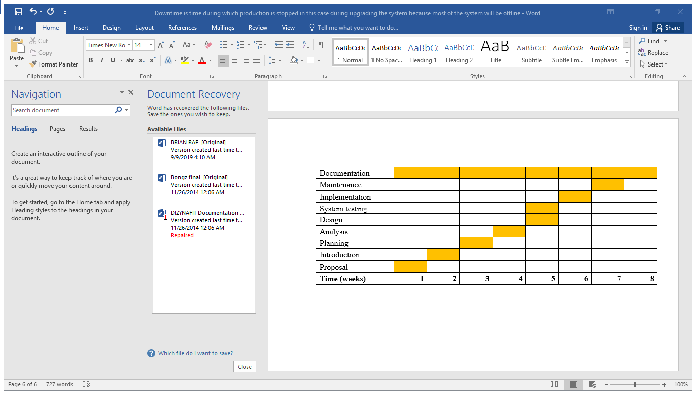

**Diagram 1: Diesel System Project Gantt Chart**

**Chapter 2 Systems Analysis**

**2.1 Data gathering methodologies employed**

Data gathering is a very important part of the research project process. It is the fourth step in the research process. The type of data-gathering method chosen will have a major impact on how activities for the rest of the research project will be undertaken. The data collection process will directly relate to your research question and analysis technique (you need to collect the right data to answer our question). Data collection can also be the biggest cost (time and money) of the research, so great care should be used when choosing the methodology for your project (Weller & Romney, 1988). Before you begin collecting data, you need to consider the following key points:

* The aim of the research
* The type of data that you will collect
* The methods and procedures you will use to collect, store, and process the data

When managing project information, managers need to do almost an interruptible task of gathering and distributing information on the activities and processes. This task turns around collecting project data that describes status, assignments and performance. Actually, these are the key information on any project. When you know current status of assignments and current level of team performance, you can make efficient decisions and solve ongoing problems. The methodologies for collecting data are:

**LITERATURE REVIEW**

This stage will focus on previous projects of the same nature that have been carried before. According to research writers, around every research undertaking there is a vast sea of literature, countless reports on what others have done (Agarwal et al, 2010: 68). They further articulate the essence of literature review as: “to find out what things are already known about your topic of interest; little can be gained by reinventing the wheel. But in addition to telling, you what is already known, the existing literature is likely to tell you what is not known in the area in other words, what still needs to be done”.

Most telecommunication companies around the world have found the need to introduce fuel monitoring systems as a way of trying to solve the problems that arise because of uninterrupted availability of power. There is need to have power in times of grid and main failures. Avery large percentage of the fuel for field application is lost. With an established connection to the fuel tank, one can make sure that you get the correct amount of fuel at fill-up and that you are notified whenever fuel levels drop at a suspicious rate (Eearnst & Young, 2011). Several operations can be done online without physically visiting a base station. These operations are:

**Alarm management:** The alarm management system enables one to immediately detect if fuel is being stolen and these alarms are directed to technicians through email of text messages.

Monitoring of fuel levels: During fuel fill up one can make sure that the agreed fuel has be put into the tank from a distant office

**Fuel fleet management:** Fuel fleet management allows one to carry out large-scale tank fleets management. These tank fleets would be having inbuilt GPS functionality. Fuel fleet management also creates secure zones with the use of what is known as geo fencing to avoid the stealing of fuel.

**Getting reports and statistics:** One can easily optimize the use of fuel using data from past trends

**Requirements Reviews**

Requirements review, also known as a walk-through, is a meeting in which you gather all of your stakeholders and walk through the requirements documentation, page by page, line by line, to ensure that the document accurately reflects everyone's knowledge of the project's goals. The author of the requirement documents, someone who understands the client's demands, a member of the design team, and the person responsible for maintaining the requirement document should all be included in the review group. It's also a good idea to bring in members who aren't directly involved in product development, such as a software quality engineer.

One method to structure the review meeting is to have each participant go over the requirements before to the meeting and mark the issues that he has questions about or that he believes deserve more clarity. Checklists can be extremely helpful in locating such objects. During the meeting, each person goes over the list of possible flaws that he has discovered. Ways to conduct requirements reviews are:

* **Set the stage:** Send out an email/calendar requirements with the document and a description of how the meeting will go.  Let everyone know that their role is to provide any feedback on the requirements and ultimately sign-off on the document.  Re-iterate this message at the [beginning of the meeting](http://www.bridging-the-gap.com/more-effective-meetings-3-things/).
* **Be prepared:** Make sure you have a few additional hard copies on hand. If possible, use a projector to project the document onto the wall.
* **Lead the walk-through section by section:** Allow enough time for everyone to read and ponder the criteria in that section. Request feedback, clarifications, and questions. Make sure the conversation is focused on the requirements rather than how to build them, what tasks need to be completed, or the marketing strategy. As updates are agreed upon by the review group, make a hard copy or make them available electronically so that everyone can see them.
* **Ask for sign off:** "I'll make these changes and send out an updated copy," you say. Is everyone ready to sign off once I've integrated all of these notes? “Do you have any unresolved issues or concerns?” Take a look around the room for a visual cue.

**Surveys**

Surveys are one way in which you can directly ask customers for information. You can use them to collect either quantitative or qualitative data or both. A survey consists of a list of queries respondents can answer in just one or two words and often gives participants a list of responses to choose from. You can conduct surveys online, over email, over the phone or in person. One of the easiest methods is to create an online survey you host on your website or with a third party. You can then share a link to that survey on social media, over email and in pop-ups on your site.

**2.2 Description of existing system**

The existing system uses manual data entry. Most data entry tasks are time consuming in nature; however, data entry is considered a basic and necessary task for most organizations. Accurately keyed data is the base upon which the organization can perform analyses and make plans. Manual data entry often requires good concentration and focus over a long duration of time, and this can prove physically and mentally challenging for data entry workers. Handling manual data entry works fine for companies who deal with few documents and have employees specifically devoted to it. However, for a large volume of documents, automatic data capture may be a better solution. The system is characterized by the following challenges:

**Human Error**

human beings are more prone to error than computers. While a computer system has the occasional glitch, it generally records data and organizes it in a more accurate way than human beings, with less need for error checking. Manual data processing requires far more eyes to check and double checking the data for accuracy.

**Speed**

It takes a lot of time to enter data manually. Machines and computers are generally faster than humans, which frees up time for employees to focus on other things. Instead of typing in numbers all day long, your employees could spend more time reviewing inventory, creating charts or drawing up projections for future growth.

**Labor Costs**

It costs a lot of money to pay people to manually enter data, physically visit the base stations and it keeps entrepreneurs and other employees from investing more time on their point of greatest contribution toward the vision and mission of the company. The job of many can now be completed by one person, which means that you need fewer data entry employees and you can use your employees in areas that better engage their gifts in order to speed up company growth.

**2.3 Activity diagram**

Activity diagram is basically a flowchart to represent the flow from one activity to another activity. The activity can be described as an operation of the system. The basic purpose of activity diagrams is to capture the dynamic behavior of the system. It is also called object-oriented flowchart.

This UML diagram focuses on the execution and flow of the behavior of a system instead of implementation. Activity diagrams consist of activities that are made up of actions that apply to behavioral modeling technology.

**Components of Activity Diagram**

**Activities**

It is a behavior that is divided into one or more actions. Activities are a network of nodes connected by edges. There can be action nodes, control nodes, or object nodes. Action nodes represent some action. Control nodes represent the control flow of an activity. Object nodes are used to describe objects used inside an activity. Edges are used to show a path or a flow of execution. Activities start at an initial node and terminate at a final node.

**Activity partition/swim lane**

An activity partition or a swim lane is a high-level grouping of a set of related actions. A single partition can refer to many things, such as classes, use cases, components, or interfaces. If a partition cannot be shown clearly, then the name of a partition is written on top of the name of an activity.

**Fork and Join nodes**

Using a fork and join nodes, concurrent flows within an activity can be generated. A fork node has one incoming edge and numerous outgoing edges. It is similar to one too many decision parameters. When data arrives at an incoming edge, it is duplicated and split across numerous outgoing edges simultaneously. A single incoming flow is divided into multiple parallel flows. A join node is opposite of a fork node as it has many incoming edges and a single outgoing edge. It performs logical AND operation on all the incoming edges. This helps you to synchronize the input flow across a single output edge.

**Pins**

Pins are used to clearing up the things. It provides a way to manage the execution flow of activity by sorting all the flows and cleaning up messy thins. It is an object node that represents one input to or an output from an action. Both input and output pins have precisely one edge.

**Diagram 2: Fuel inventory management system activity diagram**

System Administrator

Receive

Data entry clerk

Management

**2.4 DFD (Context and detailed)**

A data flow diagram (DFD) represents graphically a flow of data within a system. It illustrates how data is input and output from the system. It also shows destinations, storage, and sources of the information in the system.

**Elements of DFD**

* **Processes:** The main activities that are happening within the system boundary. The process can be as simple as collecting customer data and storing it in the company database. Also, it can be a very complicated process such as creating a report containing bank contracts with customers of all bank clones in a region.
* **External entities**: The sources of information coming to or leaving the system. External entities are outside systems such as people (customers, stakeholders, managers), organizations, computers and other systems that send or receive data from our system.
* **Data stores**: Places where data is held such as files or repositories. Data stores show information that is not moving.
* **Data flows:** Illustrate the movements that data have between the external entities, data stores, and the processes.

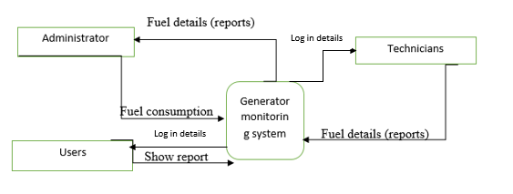**Diagram 3 Contextual diagram**

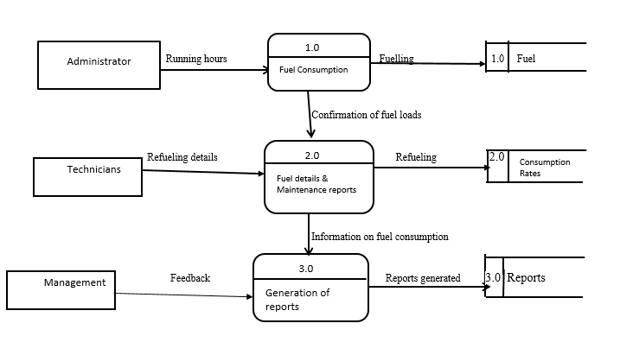

**Diagram 4: dataflow diagram of the proposed system**

**2.5 weaknesses of existing system**

Manual systems put pressure on people to be correct in all details of their work at all times, the problem being that people aren’t perfect, however much each of us wishes we were.  With manual systems the level of service is dependent on individuals and this puts a requirement on management to run training continuously for staff to keep them motivated and to ensure they are following the correct procedures.  It can be all too easy to accidentally switch details and end up with inconsistency in data entry or in hand written orders.

It takes more effort and physical space to keep track of paper documents, to find information and to keep details secure.  When mistakes are made, often a manual transaction must be completely redone rather than just updated.  With manual or partially automated systems information often has to be written down and copied or entered more than once.  Systemization can reduce the amount of duplication of data entry.

**Lack of Security**

The paper document is less secure compared to an electronic system. Misplaced of documents can easily get into wrong hands. The organization Secret or classified information is unsafe. If you lost them somewhere, there is no chance of getting them back. The leak of confidential documents can cost you a big amount. Clients expect their information to be secure in your hands. If you can’t keep this safe, you are at risk of losing them.

**Time Consuming**

Manually managing is a very tough and time-consuming process. Handling of each and every document and store them safely is not easy. It’s not only about security but also about transporting or carrying out documents at different places. Physically carry the documents and handling them is a task. But if you are using an IT tool then you can travel with years of data in just an eraser size pen-drive.

**Increases Cost**

One of the biggest drawbacks of paper- based document management system is the associated costs. These costs quickly add up can become a significant expense in larger organizations leads to decrease in the organizational profit. Documentation, record keeping and storage are very costly process in manually management system. When you use paper documents your costs are going to be higher because you are paying for ink and paper. Your office supply bill will be higher if you are using a manual document filing process. While you might think this is insignificant, overtime it’s a lot of money that can be used in better ways.

**2.6 Justification of alternative taken**

**Develop a tailor-made system using Internet of Things (IOT)**

IOT involves use of various technologies like Versatile Communication Links (IFSF, MAODBUS, Ethernet, GPRS, LTE), Embedded with Energy Management Feature, Explosion Proof Installation, Embedded Intelligence, Global Dashboard (Remote accessibility from anywhere worldwide), Alarm visualization and response action ability, Product and water level real-time monitoring, Leak detection, Fire system integration, Real-time fl­ow per nozzle, Sessions management and tracking, Rugged construction sensors, for level, pressure, and fl­ow metering, CCTV cameras, GIS, RFID, Cloud computing.

The system will be simulated which is defined by Johnson (2015) as the imitation of the operation of a real-world process or system overtime. This means certain assumptions will be made concerning how the system will operate. However, the assumptions will be represented in mathematical formats and algorithms. A code consisting of algorithms will be inserted into the system. This algorithm will calculate the fuel consumption rate and will send a notification by the means of a text message to the administrator.

In order to log in the administrator has to open and run XAMPP by typing <http://localhost/degm/> in link tab on any browser, this will lead to the log in portal even without internet connection. After logging in the administrator will be able to monitor the state of every generator and provide with another generator if any need arises. The administrator can also provide with reports that he/she can print out and present to the management. The system administrator has also the privileges of adding and removing users from the systems. These users can include technicians that will also be carrying out a closer monitoring of their respective base stations and provide their assessments to the administrator therefore enabling simulation of the whole operation.

Engines that use the electronic systems are more reliable than the contemporary ones. Problems that come with the traditional approach such as oiled spark plugs, random engine stoppages and other problems related to engine are highly eliminated. In short, having use the electronic system not only enhances reliability but also reduces the maintenance time you required earlier.

**2.7 Requirements analysis (Use Case Diagram)**

Requirements analysis is**the process of determining user expectations for a new or modified product. During analysis, the information gathered from the consumer during inception and elicitation is broadened and refined. The goal of this assignment is to create a refined requirements model that defines requirements for three domains: information, functional, and behavioral. It explains the end user's interaction with the system and the business domain entities that are visible to the end user. Each analysis class's properties are defined, and the services that each class requires are identified. A variety of supplemental diagrams are created to show the relationships and collaboration between classes. The objectives of requirements analysis are to:**

* Connect end-user needs to the system, system elements, and the ability to design and develop system elements.
* Define a system that meets end-users' operational mission requirements within specified cost and schedule constraints.
* Provide insight into the interactions among various functions to achieve a set of

balanced requirements based on user objectives.

**Diagram 5: Econet fuel inventory management system Use case**

Fuel inventory management System

**Chapter 3 System Design**

**3.1 proposed systems DFDs (Context and Detailed)**

Eppinger (2018) described a context diagram that distinguishes the software segments and the environment therefore showing the entities that relate with it. The contextual diagram of the proposed system is shown below:

**Diagram 6: Context diagram**



**DATA FLOW DIAGRAM OF PROPOSED SYSTEM**

It is a method of demonstrating movement of information of a process and also providing information about the inputs and output of a process. The diagram below shows the data flow of the proposed system.

**Diagram 7: dataflow diagram of the proposed system**



**3.2 Architectural design**

Sommerville (2017), emphasized that architectural design focuses on the mechanisms of an application and composed them into logical and operational system to explicitly achieve objectives under the provided margins. Therefore, it will be exposed to software quality analysis corresponding to any other design work. Architectural design can be represented using the following models:

**Structural model:** Illustrates architecture as an ordered collection of program components

**Dynamic model:** Specifies the behavioral aspect of the software architecture and indicates how the structure or system configuration changes as the function changes due to change in the external environment

**Process model:** Focuses on the design of the business or technical process, which must be implemented in the system

**Functional model:** Represents the functional hierarchy of a system

**Framework model:** Attempts to identify repeatable architectural design patterns encountered in similar types of application. This leads to an increase in the level of abstraction.

**Architectural Design Output**

The architectural design process results in an Architectural Design Document (ADD). This document consists of a number of graphical representations that comprises software models along with associated descriptive text. The software models include static model, interface model, relationship model, and dynamic process model. They show how the system is organized into a process at run-time. Architectural design document gives the developers a solution to the problem stated in the Software Requirements Specification (SRS).

**PHYSICAL DESIGN**

Physical design is the changing of the software application into a structure model that indicates certain user requirements established. The physical design also shows how the hardware and software interact. Thus, there should be certain modified configurations for the system to function properly.

Database Server

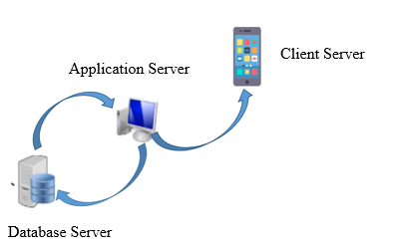

**Diagram 8: Physical Design**

**3.3 Menu Design**

**Main menu**

Several menus to choose from will be on main menu, usernames and passwords will be used to define user levels. After logging in into the system the user will get to the dashboard. The diagram below shows how the main menu will look like:

**Table 8: Main Menu**

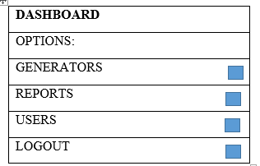

**Sub menus**

The main menu will contain sub menus with the options to select from thus the add option and the view option. The submenus will look like this:

**Table 9: Main Menu**

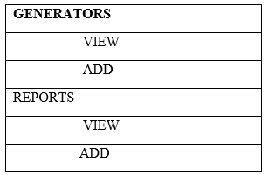

**3.4 Input Menu**

**Input design**

Inputs design are forms that are used to punch in information into the database as well as updating the information. Insertion of invalid data should be displayed on any form before the user attempts to save the information. The following will be included in the input form:

* Authentication of data before its acknowledgment by the system.
* Processes than can be triggered by some keyboard keys can also be triggered by the mouse.

**Log in form**

Entrance into the system will be granted by the input interface below. The user is obliged to submit their username and password to enter into the system, in the case of providing incorrect credentials access into the system will be denied. This implies that before even getting to the main menu one has to log in first. The diagram below shows the design of the log in form:

**Table 10: Login Form**

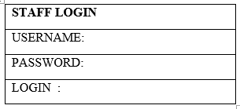

**3.5 Output design**

**Output design**

Output design will show how the system will display data upon its request by the user. Below is an illustration of the output design:

**Table 11: Output Design**

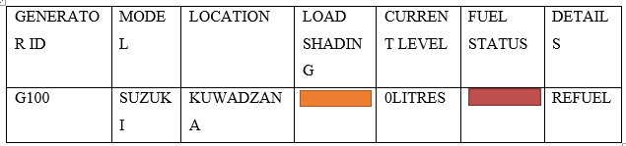

**3.6 Process design (Pseudo code, Flow charts)**

Zobel (2011), identifies a pseudo code as an informal description of the operating principle of how a computer program is to be executed or any program algorithm. Pseudo codes allow human beings to read and comprehend code since there are a simple translation of a given programming language. A pseudo code breaks some of the programming protocols that must be followed. PHP programming language will be used to develop the system. The data elements conceptualized during database design were mapped into tables and they were aligned with the respective attribute.

**Begin:**

Open XAMMP

Then run Apache and MySQL

Open browser

Open webpage localhost/degm

Input username and password

If correct Then

Login successful

Else

Messagebox access denied

Return

Choose options generators, or reports, or users, or logout

Click view or add

If correct Then

Messagebox successful

Else

Enter all field

Validate options

If options are valid Then

Write to database

Else

Display error message

End if

**Flowchart**

A flowchart is a diagram that depicts a process, system or computer algorithm. They are widely used in multiple fields to document, study, plan, improve and communicate complex processes in clear and easy to understand diagrams.

**Diagram 9: Flowchart**

Requisition Order

POP decision: pick/order

Determine quantity

create “pick serial number”

create packing slip and serial number

Create a work order

Pick up generator from current inventory

Determine order quantity

Box and package the generator

Assemble or manufacture generator

Create purchase order and send

Receive items

**3.7 Database Design (DD, ER and EER diagrams)**

Crockett (2013) described a database design as forming data components and the manner in which they are symbolized in a database. An attribute name is represented by the field name and the data type to be entered in that field is also be specified during the creation of that field. The manner in which an ordinary user views the system is different from how the administrator sees it. Below is what is known as the three architectures:

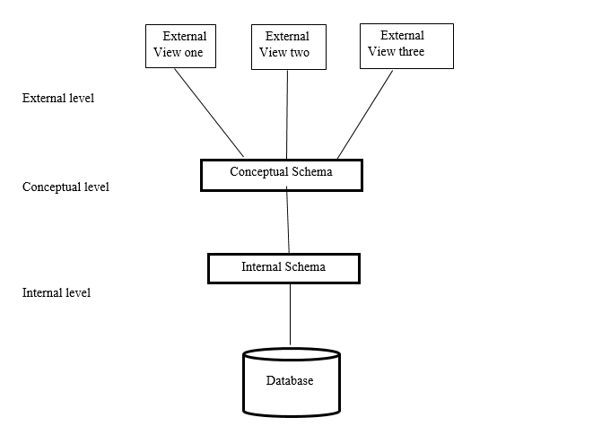

**Diagram 10: Three level architecture**

**Table 12: Administrator table**

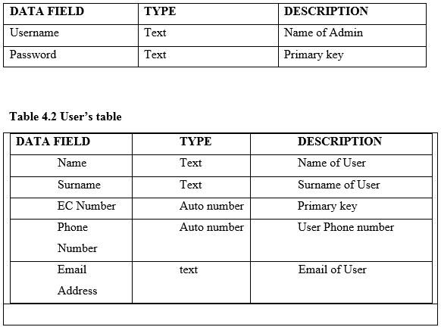

**ENTITY RELATION DIAGRAM FOR THE PROPOSED SYSTEM**

Howe (2013), described an entity relation diagram as a that displays the relationship of entity sets stored in a database. entity relation diagrams help to explain the logical structure of databases.

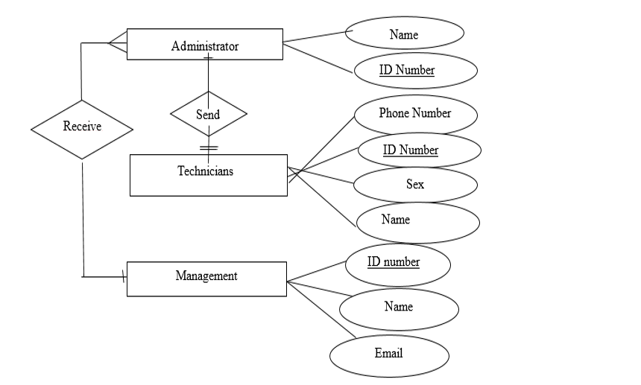**Diagram 11: Entity Relationship Diagram**

**Table 14: entity table**

|  |  |
| --- | --- |
| **ENTITY** | **ATTRIBUTE** |
| Administrator | Name, ID Number |
| Technician | Phone Number, ID Number, Sex, Name |
| Management | Name, ID Number, email |

**3.8 Program design (Class, sequence, collaboration, package)**

**Sequence Diagram**

A sequence diagram is structured in such a way that it represents a timeline which begins at the top and descends gradually to mark the sequence of interactions. Each object has a column and the messages exchanged between them are represented by arrows.

**Diagram 12: Sequence Diagram**

Tank System: Econet

Log: Log Sheet

Tank I.D: Telecoms

**Class diagram**

Class diagram is a static diagram. It represents the static view of an application. Class diagram is not only used for visualizing, describing, and documenting different aspects of a system but also for constructing executable code of the software application. Class diagram describes the attributes and operations of a class and also the constraints imposed on the system. The class diagrams are widely used in the modeling of object-oriented systems because they are the only UML diagrams, which can be mapped directly with object-oriented languages. Class diagram shows a collection of classes, interfaces, associations, collaborations, and constraints. It is also known as a structural diagram.

**Diagram 13: Class diagram**

|  |
| --- |
| **Clerk** |
| name:String  location:String |
| sendQuery ()  receiveReport () |

|  |
| --- |
| Query |
| date:Date  number:String |
| confirm ()  close () |

|  |
| --- |
| SpecialQuery |
| Date:date  Number:String |
| Confirm ()  Close ()  dispatch |

|  |
| --- |
| NormalQuery |
| Date:date  Number:String |
| Confirm ()  Close ()  Dispatch ()  Generate () |

**Package Diagram**

Package diagram is a kind of structural diagram which shows the arrangement and organization of model elements in the middle to large scale project. Package diagram can show both structure and dependencies between sub-systems or modules. It shows different views of a system, for example, as multi-layered application model.

**Diagram 14: Package diagram-Diesel Subsystem**

<<sub system>>

Reading

GUI MANAGER

UI

Consumption

processing

Storage Mana

gerent

External

Storage

volume

calculator

Stream

Storage

Random

Storage

File Storage

Repository

**Collaboration diagram**

The collaboration diagram is used to show the relationship between the objects in a system. Both the sequence and the collaboration diagrams represent the same information but differently. Instead of showing the flow of messages, it depicts the architecture of the object residing in the system as it is based on object-oriented programming. An object consists of several features. Multiple objects present in the system are connected to each other. The collaboration diagram, which is also known as a communication diagram, is used to portray the object's architecture in the system.

**Diagram 15: Collaboration diagram**

Window: UserInterface

aSystem: DieselSystem

aNotice

confirmation

aReading:

Reading

aDiesel: Diesel

**3.9 Test data design**

Limaye (2013) states that testing customarily involves the implementation of system components so as to assess one or more properties. The following issues show the extent to which the system is put to test:

* The system should respond to different data inputs in different manners.
* The system should address all the desires of the users.
* Execution of certain functions should start and finish within the expected time.
* The system should be compatible with the environment it is supposed to operate in.

Considering that the system development has been done, it is important that the system has to be tested before it is implemented. Testing of the system is essential since there is a need to find out if there are no errors hindering the system operations. If any errors are discovered during the testing, measures will be taken instantly to get rid of these. Testing procedures are done one after the other repeatedly until the system stops producing errors. The following diagram shows how testing will be done in stages.

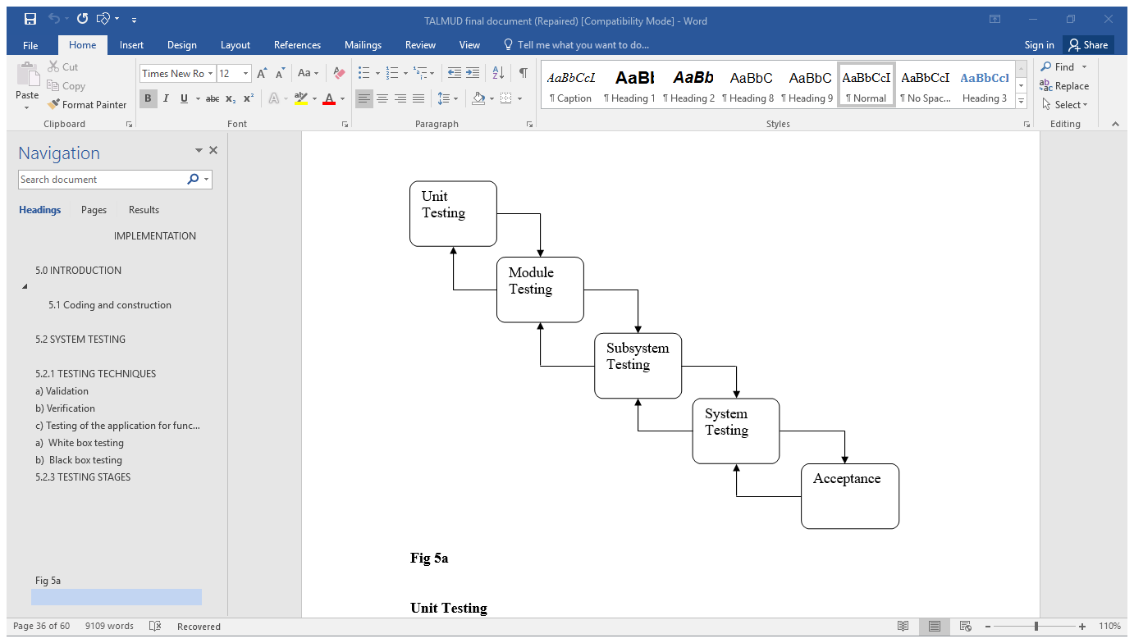

**Diagram 16: Testing** **stages**

**UNIT TESTING**

According to Galitz (2014), unit testing is a product advancement process whereby little parts of the system or rather sub modules of the system are tested independently in order to find out if they are operating as expected and serving their purpose. All the testable units of the system were tested to discover if they were all meeting the developer ‘s intentions and collaborating to form a well functional system. The log in forms and add forms were tested to find out if they were authenticating data effectively as expected. The techniques below were used:

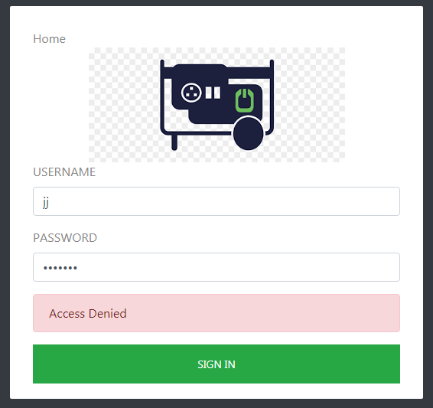

**Diagram 17: Unit Testing**

**BLACK BOX TESTING**

Galitz (2014) refers black box testing as functional Testing. This test was done with little attention to the system’s structure but rather what the system is supposed to do. This included testing of inputs units within the system therefore logging in as well as adding things into the system for example a new generator or user. The results form tests were based on the outputs of the system for example “You have successfully logged in”,

“User successfully added” etc.

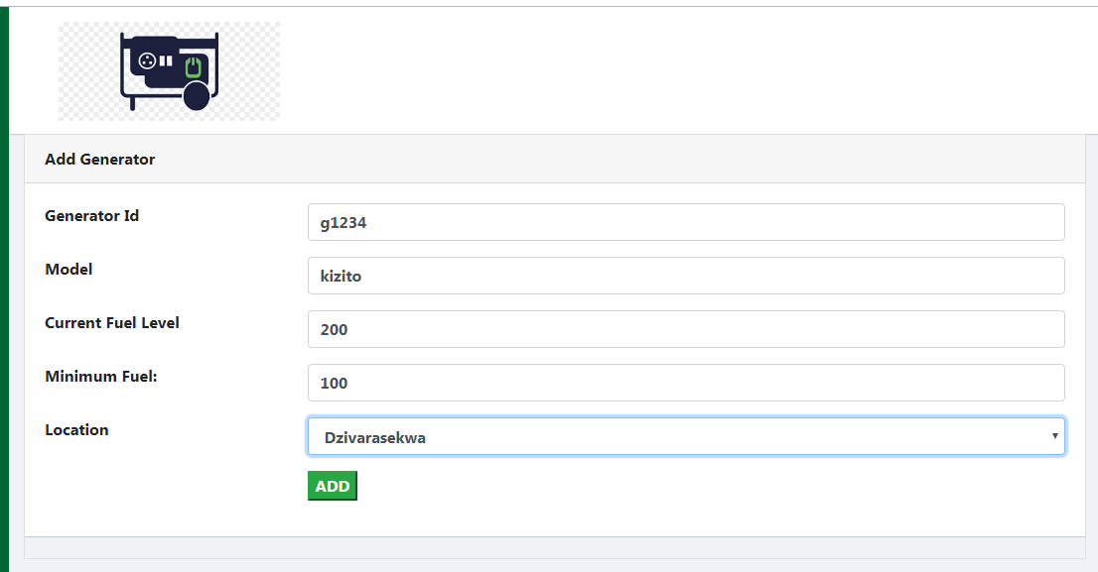

**Diagram 18: Black Box Testing**

**WHITE BOX TESTING**

This is referred to as Structural Testing, Galitz (2014). Unlike black box testing, white box testing pays more attention to the inside processes of the system. White box testing prioritizes details of the internal operations, it unearths errors that are not revealed through black box testing. The researcher implemented white box testing to discover if the system code was working properly.

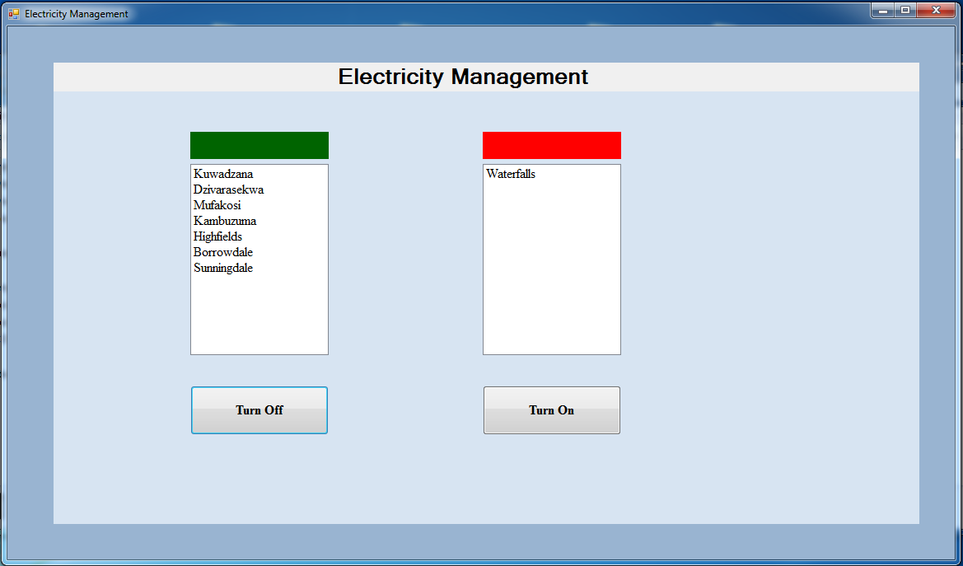

**Diagram 19: White Box Testing**

**MODULE TESTING**

Sommerville (2017) defined module testing as a process of testing the individual subprograms, subclasses, and procedures in a system. Module testing is an alternative way of testing which focuses on testing smaller modules within the system as compared to testing the whole system at large. Module testing is white box testing in nature since it does not seek to find out if a module is working properly but rather seeks to uncover errors within that module. Several aspects were tested in modules for example the administrator’s module. Other modules that were put to test include user profiles as well as generator modules. After testing several modules one by one, the modules were then combined into one big module and tested again.

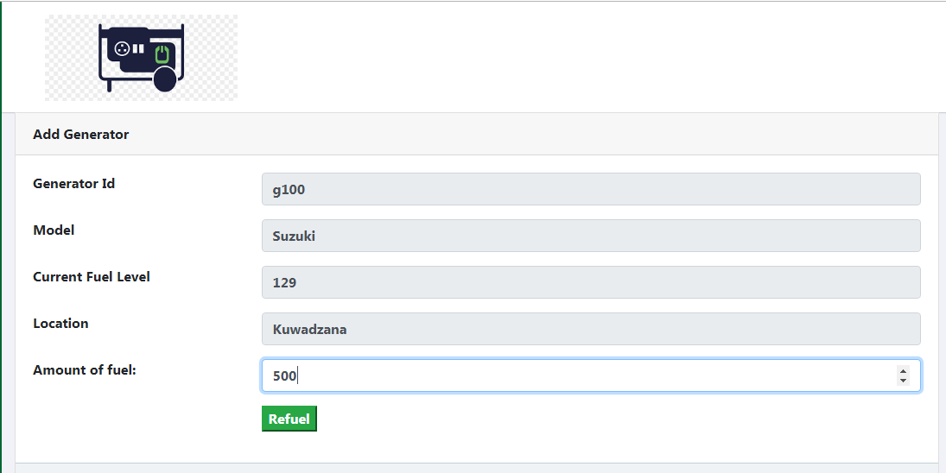

**Diagram 20: Module Testing**

**SUB SYSTEM TESTING**

According to Lumaye (2013), sub system testing is the testing of some of the combined modules within the system but not all. Sub system testing was carried out by executing two or more modules within the system to see if they are effectively collaborating and working as expected. The database of the system was put to test as an independent subsystem of the system. However, a few problems were encountered during sub system testing and one of them was the mismatching of interfaces. Another sub system that was tested involved the administrator and two users in which the administrator had to restrict the other user. This was carried out and it worked.

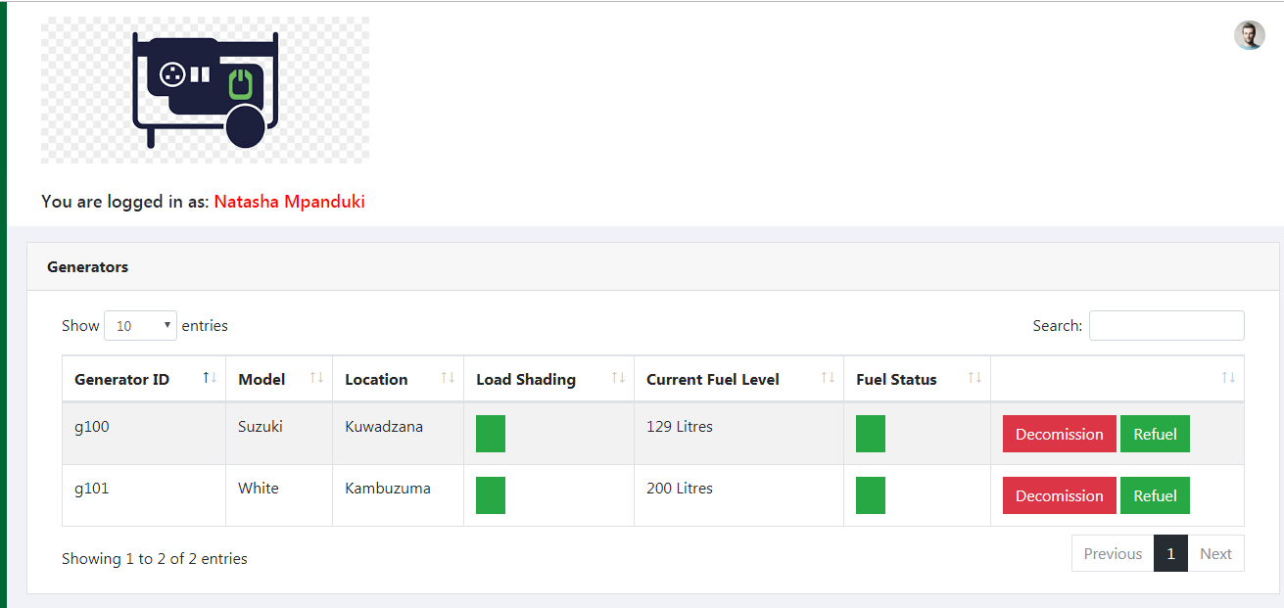

**Diagram 21 Sub System Testing**

**SYSTEM TESTING**

As alluded to by Boehm (2008) in system testing, the sub-systems are integrated and combined to make up the entire system. A compilation of the system is done and it is tested as one big system. This is attained through:

Functionality Testing - It includes testing all the system functions in comparison with the requirements set.

Performance Testing - This testing was carried out to confirm the system’s level of efficiency and effectiveness. Several tests were carried out with the goal to discover the time taken by a system to perform certain functions under different circumstances for examples when the number of users was to increase in the system. These tests were also carried out to discover system errors and the average time it takes to recover from these errors. Performance testing was basically carried out by overloading the system and putting it under unfavorable conditions for example overloading it with users or executing many operations at once.

**ACCEPTANCE TESTING**

To make sure that the system is going to be embraced by its users, they have to come in contact with the system. This is crucial because even if the system is created as per the users’ requirements the same users may disagree with other aspects of the system therefore the general display of the system for example the font, colors or even shape of the interfaces.

This is the last stage and then the system is put to operation officially. This is another stage where errors might come up and the developers might have missed those in the previous testing stages. At this stage the administrator is the one who tested the system together with a few other users so as to find out if the system met their requirements. The system was installed to a portion of the users and the feedback that came back to the development team was positive. Acceptance test was mainly done to find out if the users would accept the system. Two techniques were used to do acceptance test and these were alpha testing and beta testing.

**ALPHA TESTING**

According to Kendal (2012), alpha testing is a simulated approach whereby a group of potential users/customers or an independent test team test the functionality and usability of the new system at the developer’s site. The test was done by using the system in a manner that feels like it’s being used in a real working atmosphere. The main objective was discovering the users’ reactions to certain actions done by the system as well as the system’s response to the inputs from the users.

**BETA TESTING**

Beta testing comes after alpha testing and it aims to test the external users of the system. According to Kendel (2012), there are beta versions of every software and these are put out to a limited number of people also referred to as beta testers. It is conducted after the alpha test and is considered a form of external user acceptance testing. Nevertheless, the beta version is in most cases not the final version. The software was fed with the exact nature of data it was going to work with and not artificial data. Errors came up and they were addressed.

**3.10 Security and Backup design**

System security encompasses all facets of accessing information assets.  From authentication, to software updates, anti-virus protection, and modifications - security is a key component to a device operating at its optimum.  These best practices help to mitigate various security concerns.

**Security System Goals**  
**Integrity**   
The objects in the system mustn’t be accessed by any unauthorized user & any user not having sufficient rights should not be allowed to modify the important system files and resources.

**Secrecy**  
The objects of the system must be accessible only to a limited number of authorized users. Not everyone should be able to view the system files.

**Availability**  
All the resources of the system must be accessible to all the authorized users for example only one user/process should not have the right to hog all the system resources. If such kind of situation occurs, denial of service could happen. In this kind of situation, a malware might hog the resources for itself and thus preventing the legitimate processes from accessing the system resources.

**Measures to eliminate security threats**

**Utilize data classification**  
Identifying the type of data collected, stored, and transmitted will help in identifying controls to be utilized to secure the information assets of an institution.  Some data must be classified as confidential due to federal regulations, while other data might be classified public or directory information.  Security controls utilized will be stronger for confidential data than those for public information.  Data classification can help institutions to prioritize security efforts.

**Implement and follow patch management strategy**  
All software requires regular maintenance to maintain its peak functionality.  As technology manufacturers are made aware of problem areas in their product(s), they release a patch, update, or service pack. These ‘patches can range from fixing simple cosmetic problems (low impact) to resolving an issue that would allow full control of the system from an unauthorized source (critical impact).  An institution should deploy a process for patch management on critical infrastructure and services.

**Utilize system logs for audit trails**

Knowing what changes are made to the university information assets, who made those changes, and when those changes were made are important steps in maintaining the confidentiality, integrity, and availability of the information assets.  To assist in this effort, an audit trail of system activity should be maintained for each system, for each type of user, including system administrators.  This information must be reviewed regularly.

To help with the log management, common security practices include the use of a log aggregation solution and deploying a security information and event management (SIEM) tool.  Aggregating all system logs into one solution, and utilizing features such as monitoring and alerting for anomalies in the logs can help identity problems quicker for system administrators.



**Diagram 22: Login Form**

**System Backup**

A system backup is the process of backing up the operating system, files and system-specific useful and essential data. Backup is a process in which the state, files and data of a computer system are duplicated to be used as a backup or data substitute when the primary system data is corrupted, deleted or lost.

System backup primarily ensures that not only the user data in a system is saved, but also the system's state or operational condition. This helps in restoring the system to the last-saved state along with all the selected backup data. Generally, the system backup is performed through backup software and the end file (system backup) generated through this process is known as the system snapshot/image. Moreover, in a networked/enterprise environment, the system backup file/snapshot/image is routinely uploaded and updated on an enterprise local/remote storage server

**3.11 Test data design**

Limaye (2013) states that testing customarily involves the implementation of system components so as to assess one or more properties. The following issues show the extent to which the system is put to test:

* The system should respond to different data inputs in different manners.
* The system should address all the desires of the users.
* Execution of certain functions should start and finish within the expected time.
* The system should be compatible with the environment it is supposed to operate in.

Considering that the system development has been done, it is important that the system has to be tested before it is implemented. Testing of the system is essential since there is a need to find out if there are no errors hindering the system operations. If any errors are discovered during the testing, measures will be taken instantly to get rid of these. Testing procedures are done one after the other repeatedly until the system stops producing errors. The following diagram shows how testing will be done in stages.



**Diagram 16: Testing stages**

**UNIT TESTING**

According to Galitz (2014), unit testing is a product advancement process whereby little parts of the system or rather sub modules of the system are tested independently in order to find out if they are operating as expected and serving their purpose. All the testable units of the system were tested to discover if they were all meeting the developer ‘s intentions and collaborating to form a well functional system. The log in forms and add forms were tested to find out if they were authenticating data effectively as expected. The techniques below were used:



**Diagram 17: Unit Testing**

**BLACK BOX TESTING**

Galitz (2014) refers black box testing as functional Testing. This test was done with little attention to the system’s structure but rather what the system is supposed to do. This included testing of inputs units within the system therefore logging in as well as adding things into the system for example a new generator or user. The results form tests were based on the outputs of the system for example “You have successfully logged in”,

“User successfully added” etc.



**Diagram 18: Black Box Testing**

**WHITE BOX TESTING**

This is referred to as Structural Testing, Galitz (2014). Unlike black box testing, white box testing pays more attention to the inside processes of the system. White box testing prioritizes details of the internal operations, it unearths errors that are not revealed through black box testing. The researcher implemented white box testing to discover if the system code was working properly.



**Diagram 19: White Box Testing**

**MODULE TESTING**

Sommerville (2017) defined module testing as a process of testing the individual subprograms, subclasses, and procedures in a system. Module testing is an alternative way of testing which focuses on testing smaller modules within the system as compared to testing the whole system at large. Module testing is white box testing in nature since it does not seek to find out if a module is working properly but rather seeks to uncover errors within that module. Several aspects were tested in modules for example the administrator’s module. Other modules that were put to test include user profiles as well as generator modules. After testing several modules one by one, the modules were then combined into one big module and tested again.



**Diagram 20: Module Testing**

**SUB SYSTEM TESTING**

According to Lumaye (2013), sub system testing is the testing of some of the combined modules within the system but not all. Sub system testing was carried out by executing two or more modules within the system to see if they are effectively collaborating and working as expected. The database of the system was put to test as an independent subsystem of the system. However, a few problems were encountered during sub system testing and one of them was the mismatching of interfaces. Another sub system that was tested involved the administrator and two users in which the administrator had to restrict the other user. This was carried out and it worked.



**Diagram 21 Sub System Testing**

**SYSTEM TESTING**

As alluded to by Boehm (2008) in system testing, the sub-systems are integrated and combined to make up the entire system. A compilation of the system is done and it is tested as one big system. This is attained through:

Functionality Testing - It includes testing all the system functions in comparison with the requirements set.

Performance Testing - This testing was carried out to confirm the system’s level of efficiency and effectiveness. Several tests were carried out with the goal to discover the time taken by a system to perform certain functions under different circumstances for examples when the number of users was to increase in the system. These tests were also carried out to discover system errors and the average time it takes to recover from these errors. Performance testing was basically carried out by overloading the system and putting it under unfavorable conditions for example overloading it with users or executing many operations at once.

**ACCEPTANCE TESTING**

To make sure that the system is going to be embraced by its users, they have to come in contact with the system. This is crucial because even if the system is created as per the users’ requirements the same users may disagree with other aspects of the system therefore the general display of the system for example the font, colors or even shape of the interfaces.

This is the last stage and then the system is put to operation officially. This is another stage where errors might come up and the developers might have missed those in the previous testing stages. At this stage the administrator is the one who tested the system together with a few other users so as to find out if the system met their requirements. The system was installed to a portion of the users and the feedback that came back to the development team was positive. Acceptance test was mainly done to find out if the users would accept the system. Two techniques were used to do acceptance test and these were alpha testing and beta testing.

**ALPHA TESTING**

According to Kendal (2012), alpha testing is a simulated approach whereby a group of potential users/customers or an independent test team test the functionality and usability of the new system at the developer’s site. The test was done by using the system in a manner that feels like it’s being used in a real working atmosphere. The main objective was discovering the users’ reactions to certain actions done by the system as well as the system’s response to the inputs from the users.

**BETA TESTING**

Beta testing comes after alpha testing and it aims to test the external users of the system. According to Kendel (2012), there are beta versions of every software and these are put out to a limited number of people also referred to as beta testers. It is conducted after the alpha test and is considered a form of external user acceptance testing. Nevertheless, the beta version is in most cases not the final version. The software was fed with the exact nature of data it was going to work with and not artificial data. Errors came up and they were addressed.

**3.12 deployment diagram**

A deployment diagram is a UML diagram type that shows the execution architecture of a system, including nodes such as hardware or software execution environments, and the middleware connecting them. Deployment diagrams are typically used to visualize the physical hardware and software of a system.

**Diagram 23: Deployment Diagram for Diesel system**



**Chapter 4 System Implementation**

**4.1 Testing plan/ Evaluation/ Verification**

A Test Plan is a detailed document that describes the test strategy, objectives, schedule, estimation, deliverables, and resources required to perform testing for a software product. Test Plan helps us determine the effort needed to validate the quality of the application under test. The test plan serves as a blueprint to conduct software testing activities as a defined process, which is minutely monitored and controlled by the test manager.

|  |  |  |
| --- | --- | --- |
| **Task Name** | **Start Date** | **End date** |
| Making test specification | 02/03/22 | 02/07/22 |
| Milestone | 02/07/22 | 02/07/22 |
| Perform test execution | 02/10/22 | 02/19/22 |
| Milestone | 02/26/22 | 02/26/22 |
| Test report | 02/20/22 | 02/25/22 |
| Milestone | 02/25/22 | 02/25/22 |
| Test delivery | 02/26/22 | 02/29/22 |
| Milestone | 02/29/22 | 02/29/22 |

**Table 15: Testing Plan**

**EVALUATION**

Boehm (2019) defined evaluation as a process of checking that the system design satisfies or fits the intended purpose therefore are the user requirements being met by the software. This was achieved through dynamic testing, the major goal for validating is to ascertain if user requirements are being met by the system. This was attained by comparing the system’s functions with the requirements of the users. With the goal to attain validation as well the system’s data output was also compared to its data input.

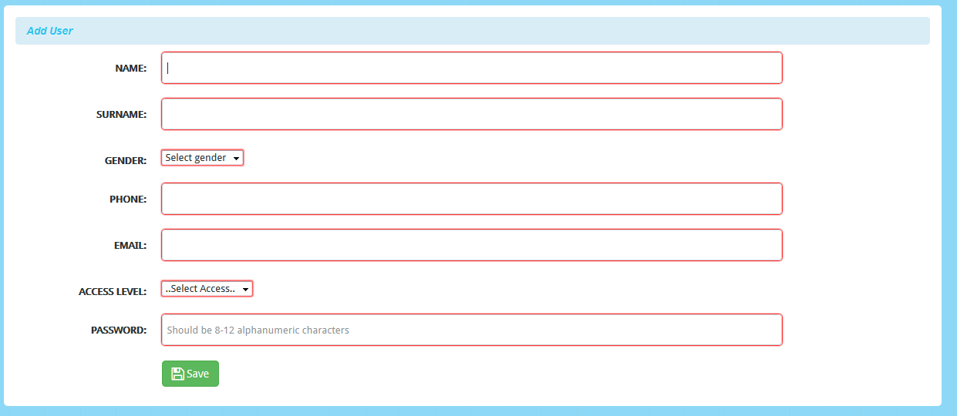

**Diagram 24: Evaluation**

**VERIFICATION**

Verification checks if the system was developed correctly. Most people confuse verification and validation. However, these two are not the same. Boehm (2019), describes:

**Validation**: Is the software that we are building the right one?

**Verification:** Is the software being developed in a right manner?

Verification mainly focuses on finding out if the user’s expectations met with the developed system. When the developed system was compared with the user requirements there was a perfect match. On the other hand, verification checked if the validation was carried out correctly and met its objectives.





**Diagram 25: Verification**

**4.2 Installation and conversion**

Diesel monitoring system is typically installed inside an enclosure with other devices. Therefore, the installation of the instrumentation must take into consideration that the panel layout accommodates all the necessary components. In addition to the panel layout, the following specifications should be considered:

* Electronic instrumentation can be affected by interference from other electronic devices. This interference causes static that may interrupt communications or signals from other devices. Use these guidelines to prevent any possibility of interference with your equipment.
* Environmental specifications that cover the operating temperature, humidity, vibration, noise and immunity.
* Power requirements are specific to each piece of equipment. When installing the system always make sure to follow the manufacturer’s power requirement guidelines.

The startup of our automated control system begins once we have installed our control system enclosure and auxiliary equipment, terminated all field wiring, and completed required testing. This process is also called “commissioning” the automated control system and related equipment/process. As a starting point, it is best to isolate the various sections of our control system power wiring by removing the fuses and/or opening circuit breakers.

The best tool to use during commissioning is the schematic diagrams. We will want to start at the incoming power, and basically work our way through the entire schematic. As a first step, we may want to apply power to the main circuit breaker or fused disconnect of our control system. Then, measure the voltage for proper values, phase to -phase and each phase-to-ground, if the incoming power is three phases.

Next, we turn on the main circuit protector and check the voltage at each device that is fed from the main source. Then start turning the circuit breakers on or replace the fuses one circuit at a time and make additional voltage checks and test equipment operation that may be powered from the circuit. Measure voltages as you go. Finally, will connect a PC to the diesel system and monitor the ladder logic to make sure conditions and states are responding correctly. If they are responding well, then the system is successfully installed.

**CONVERSION**

Shifting from manual to automated diesel systems can be a shock that can take some time to getting used to by some employees of Econet. However, the change is the most integral part of the organization in improving working procedures and standards. While it may seem that there is a lot of work involved in making the switch, most of that work is front-loaded and will only have to be done once, while the benefits will keep on coming. The procedures to be taken when converting from manual system to diesel automated system are:

**Automate system using rules:** Automated systems are based strongly on defined rules and parameters. The diesel system rules are defined when system administrators set up configurations after software has been created. Examples of rules may include setting the system up to send out automatic notifications when staffing levels are below a certain point or automatically alerting all employees in the company when a change has been made regarding performance expectations.

**Define rules for the system:** The effectiveness of an automated diesel system is directly reliant upon the quality and specificity of defined rules. Every single action that is taken when using self-service, submitting an application, or any other function available in the system should bring about a reaction that helps the user to achieve a specific goal. System administrators must think ahead when setting rules so that each action is productive and there are no “dead ends.”

**Starting Simple:** The diesel generator systems allow the organization to adopt only the desired features, which can be very helpful when first getting on board with the technology. By starting simple and only adopting a few features of the system, analysts can limit the number of rules that must be defined and gauge how well the system works based on the criteria that were put in place. After seeing the rules and systems in action, the organization may choose to automate more diesel generator system processes or make changes to the existing rules.

**Responding to Input:** Automating diesel generator systems can be a great way to get rid of the company of mundane manual tasks and increase efficiency. Adopting a new diesel system should always be thought of as a work in progress in which input is valuable. Users of the new system are bound to give input, so the organization should be prepared to accept and respond to that input to improve the system.

**Run parallel systems testing:** Use both the manual system and the computerized system for a temporary period of time. This will ensure that the new computerized system operates as expected.

**Discontinue manual system:** At the end of the parallel testing, you can discontinue the manual system once everything on the computerized end is working properly. All of the records from the manual system should be packed up and stored as archives.

**4.3 Conversion method used in the system implementation**

**Parallel conversion**

It is an approach wherein both the old and the new system operate simultaneously for some time. The outputs from both the systems are compared and difference is reconciled. The advantage of this conversion is that it gives a high degree of protection to the organization from the failure in the new system and has gained a wide spread popularity.

The disadvantage will be the costs associated with duplicating facilities and the personnel to maintain the dual systems. In parallel conversion a target data should be set to indicate when this conversion can be withdrawn and the new system will operate on its own. If the differences occur between the old and new systems, it should be verified with the same inputs to make sure of the transaction.

**Phase-In Conversion**

Phase-In conversion is similar to the Modular Approach but here the system itself is segmented and not the organization as in Modular Approach. The new data collection activities are implemented and an interface mechanism with the old system is developed. This interface allows the old system to operate with the new input data. Like this, separate segments are installed until entire system in implemented.

The advantage of this is that the rate of change in a given organization can be minimized and the data processing resources can be acquired gradually over an extended period of time. The disadvantage is that the costs are incurred to develop temporary interfaces with old systems.

**CHAPTER 5**

**References**

Ahmed, A., Kovo, I., Ibrahim, O., and Agbo, A. (2014). Health, Risk and Safety of Petrol Stations in Minna Town: An over View. World Applied Sciences Journal, 32 (4), 655-660,

Aishwarya, J., Lajari, P., Leena, P., and Sonawane, A. (2017). smart automatic petrol pump system. International Journal of Advance Research in Science and Engineering, 6(2), 17-29.

Alberto, A., André, B., Bruno, E., Sérgio, Ba., Eduardo, R., Fátima, L., Gonçalo, J., João, G., and Anabela, O. (2018). An oil risk management system based on high-resolution hazard and vulnerability calculations. Ocean and Coastal Management, 1(3),1-18.

Ali, N., Nazrul, I., Shougat, H., and Ruhul, A. (2015). A New Automation Approach for Fuel Station Management System. Nevşehir Bilim ve Teknoloji Dergisi Cilt, 4 (2), 99-107.

Aniket, H., Rajan, S., Priyanka, M., Kishori, D., and Prafulla, P. (2014). Multi-Automized Fuel Pump With User Security. International Journal of Scientific and Technology Research,3(5), 2277-8616.

Areeg, A., Siddig, A., and Mohamed, A. (2017). Fuel management system. 2017 International Conference on Communication, Control, Computing and Electronics Engineering (ICCCCEE), Khartoum, Sudan

Chefi, T., and Nasr, A. (2016). Optimisation techniques for planning the petrol replenishment to retail stations over a multi-period horizon. International Journal of Operational Research, 27(1).25-36.

Christman, G. L., and William, G., “Automated fueling system with remote service facility to operate multiple refueling stations” U.S. Patent 6,390,151, issued May 21, 2002.

Chukwudi, G., and Alagbe, A. (2015). Site Suitability Assessment of Petrol Filling Stations (PFSs) in Oyo Town, Oyo State, Nigeria: a Geographic Information Systems (GIS) Approach. IOSR Journal of Environmental Science, Toxicology and Food Technology.9(12), 08-19*.*

Bentley and Whitten, (2014), System Analysis and Design, McGraw-Hill Company.

Eppinger. (2018), Technology for Process Selection, Springer Shop. USA.

Galitz, W.O. (2014). The Essential Guide to User Interface Design: An Introduction to GUI Design, Wiley Publishing, Inc.: Indianapolis

Gupta, P. (2011). Structured System Analysis and Design, Firewall Media: New Delhi

Highsmith, J. (2013). Adaptive Software Development: A Collaborative Approach to Managing Complex Systems. Addison-Wesley. Hintze. S (2014), Value chain marketing, a marketing strategy to overcome immediate customer innovation resistance, Springer: New York

Kendall, J.E and Kennel (2012), Systems Analysis and Design, McGraw Hill, India

Limaye, M.G. (2013). Software Testing: Principles, Techniques & Tools, Tata McGraw-Hill Education Private Ltd: New Delhi

Sommerville, C (2017), Principles of database, Prentice Hall, United Kingdom